January 15, 2026

Contact:
For Media Inquiries Only
communications@nola.gov
(504) 658-4945

Temporary Roadway Closure of Prentiss Ave (Arts St to Painters St)
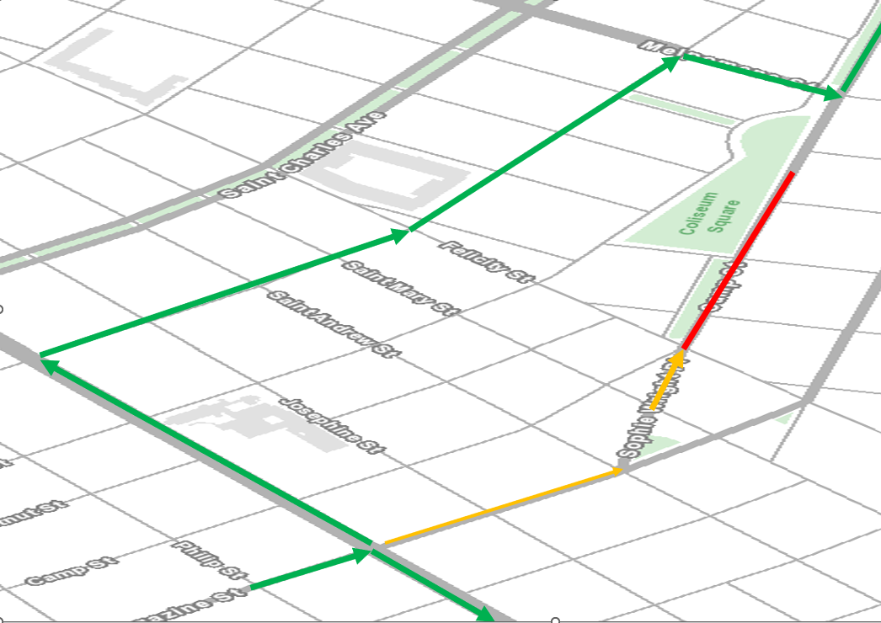
NEW ORLEANS – Beginning at 7 a.m. on Tuesday, January 20, 2026, the City of New Orleans, Department of Public Works’ contractor, Hard Rock Construction, LLC., will temporarily close the 2500 block of Prentiss St (Arts St to Painter St) approximately four weeks to accommodate utilities construction as part of the Milneburg- Treme 2025 construction project. Public safety is our top priority; signage and traffic control measures such as signage and fencing will be onsite to direct drivers and pedestrians.

During this closure, traffic will be rerouted to Mendez St. Residents and businesses in this area have been notified of the closure via next door and written notifications.

This temporary closure is part of $2.5M Milneburg-Treme 2025 joint infrastructure project with the City of New Orleans’ Department of Public Works and Sewerage and Water Board of New Orleans.

Once complete, residents will experience an overall improved quality of life as the project will improve drainage, repair streets, curbs and sidewalks and install new Americans with Disabilities Act (ADA)-compliant curb ramps at intersections. The project is scheduled to be completed in Summer 2026.

Questions about this work contact Office of Strategic Engagement directly at 504.658.7623 or OSE@NOLA.GOV
To better serve our residents with more timely communication the Office of Strategic Engagement is in the process of building our distribution list to provide important construction updates through text messaging. To sign up, text BUILDNOLA to 77295 or go to ready.nola.gov/alerts create a profile and select the “roadwork” alert list.
###
Since May 2018 DPW has completed 244 projects with an estimated value of $1.4 Billion. 37 roadwork projects currently under construction with an estimated value of $393 million.

ABOUT ROADWORKNOLA
The City of New Orleans Department of Public Works (DPW) and Sewerage and Water Board of New Orleans (SWBNO) are working together to implement an unprecedented program to restore our damaged infrastructure. Using local and federal funds, the $2.3 billion program is the most comprehensive that our region has seen in a generation.
WHAT YOU SHOULD KNOW ABOUT ROADWORKNOLA
- More than $2.3 billion worth of DPW / SWBNO work across the City
  - Includes FEMA-funded roadwork work via the approximately $2 billion Joint Infrastructure (JIRR) Program
  - $250 million FEMA-funded Hazard Mitigation Grant Program (HMGP) projects
  - $141 million HUD-funded National Disaster Resiliency Competition (NDRC) grant projects
  - SWB-funded Sewer System Evaluation and Rehabilitation Program (SSERP) (sewer consent decree)
  - City-funded bond project work
- Nearly 200 individual projects -- every neighborhood will feel this positive impact
- Project schedules coordinated to minimize construction-related impacts
- Economic opportunity for the City’s small and disadvantaged businesses
- Proactive communications so that residents are well informed throughout the program

