January 28, 2026

Contact:
For Media Inquiries Only
communications@nola.gov
(504) 658-4945

Temporary Roadway Closure of Orange St (Annunciation St to St Thomas St)
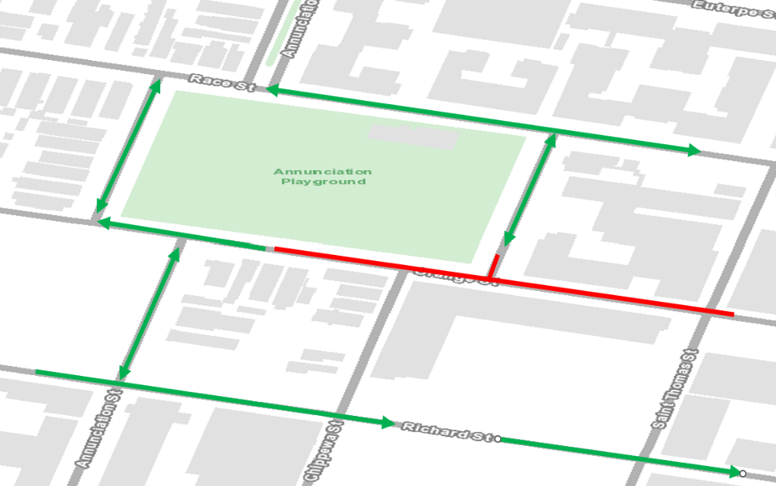
NEW ORLEANS – Beginning at 7 a.m. on Monday, February 2, 2026, the City of New Orleans, Office of Stormwater & Green Infrastructure’s contractor, RNDG Infrastructure, LLC., will temporarily close the 700 and 800 blocks of Orange St approximately eight weeks to accommodate utilities construction as part of the DPS01 Watershed (Broadmoor HMGP) Drainage Upgrades and Green Infrastructure Project (Phase I) construction project. Public safety is our top priority; signage and traffic control measures such as signage and fencing will be onsite to direct drivers and pedestrians.

During this closure, traffic will be rerouted to Race St (north and south bound). Residents and businesses in this area have been notified of the closure via a next door and notifications.

The $39.4M DPS 01 Watershed Drainage Upgrades and Green Infrastructure project is a two-phased implementation approach to reduce flooding, particularly in the Broadmoor and Central City neighborhoods, and implement green infrastructure (GI) features in the stormwater drainage system to reduce runoff and create and enhance public landscape and park amenities. This will be accomplished by upgrading the City’s stormwater drainage infrastructure to include stormwater detention features, infiltration, and landscape features along with street upgrades. In general, the contractor is working from 7 a.m. until sunset, Monday thru Friday. The entire project is scheduled to be completed by the Winter 2026, weather permitting.

Please visit roadwork.nola.gov for more information. Questions about this projects or infrastructure should be directed to 504.658.7623 or ORS@NOLA.GOV.

To better serve our residents with more timely communication, the Office of Resilience & Sustainability is in the process of building our distribution list to provide important construction updates via text messaging. Sign up for text alerts by texting BUILDNOLA to 77295 or go to ready.nola.gov/alerts to create a whole profile and select the “Infrastructure Alerts”.
###

