March 26, 2026

Contact:
For Media Inquiries Only
communi@nola.gov
(504) 658-4945

Temporary Lane Closure on Magazine (Felicity St to Race St)

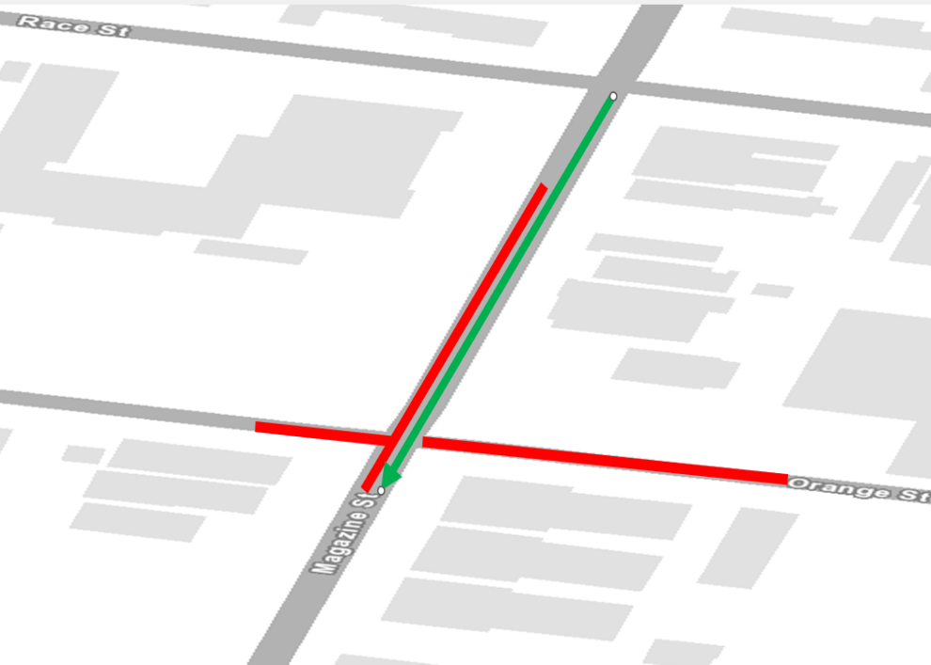
NEW ORLEANS – Beginning at 7 a.m. on Monday, March30, 2026, the City of New Orleans, Office of Sustainability , division of Stormwater & Green Infrastructure contractor, RNDG Infrastructure, LLC., will begin a single lane closure on Magazine St. in the intersection of Orange St for approximately two weeks to accommodate the drainage installation as part of the DPS01 Watershed (Broadmoor HMGP) Drainage Upgrades and Green Infrastructure Project (Phase I) construction project. Public safety is our top priority; signage and traffic control measures such as signage and fencing will be onsite to direct drivers, cyclists and pedestrians.

During this closure, traffic will be slower but still able to pass on one single travel lane. Residents and businesses in this area have been notified of the closure via a next door and notification.

The $39.4M DPS 01 Watershed Drainage Upgrades and Green Infrastructure project is a two-phased implementation approach to reduce flooding, particularly in the Broadmoor and Central City neighborhoods, and implement green infrastructure (GI) features in the stormwater drainage system to reduce runoff and create and enhance public landscape and park amenities. This will be accomplished by upgrading the City’s stormwater drainage infrastructure to include stormwater detention features, infiltration, and landscape features along with street upgrades. In general, the contractor is working from 7 a.m. until sunset, Monday thru Friday. The entire project is scheduled to be completed by the Winter 2026, weather permitting.

Please visit roadwork.nola.gov for more information. Questions about this projects or infrastructure should be directed to ORS@NOLA.GOV.

To better serve our residents with more timely communication, the Office of Sustainability is in the process of building our distribution list to provide important construction updates via text messaging. Sign up for text alerts by texting BUILDNOLA to 77295 or go to ready.nola.gov/alerts to create a whole profile and select the “Infrastructure Alerts”.
###

